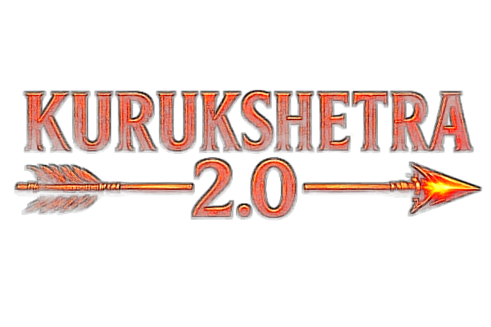
HACKFEST 2026

Problem Statement Documentation & Technical Submission
(Template / Dummy Format – for Team Reference)
Team ID | KH127
Team Name | Binary Brains
Team Leader Name | Sanchi Mane
Problem Statement No. | PS19
Problem Statement Name | Security Telemetry Correlation & Attack Reconstruction Engine
Date of Submission | 11-9-2026

SECTION 1 — TEAM DETAILS

Team ID
KH127

Team Name
Binary Brains

Team Leader Name
Sanchi Mane

Team Members Name(s)
Bhavika Sawant

Problem Statement Number
PS19

Problem Statement Name
Security Telemetry Correlation & Attack Reconstruction Engine

SECTION 2 — UNDERSTANDING OF THE PROBLEM
Problem Statement
Modern cyberattacks generate vast amounts of fragmented telemetry across authentication, endpoint, network, and application environments. These security events are heterogeneous, independently generated, and often noisy, inconsistent, or incomplete, making it difficult for analysts to correlate related events and reconstruct the actual progression of a multi-stage attack.
Analysts must manually determine *which events are related, the correct chronological sequence, how different users, hosts, processes, and network connections are connected, and whether available telemetry provides sufficient visibility into the attack*. Missing or incomplete telemetry can further obscure critical stages of an attack and lead to fragmented or misleading investigations.
The core problem is the lack of a unified and defensible way to reason across fragmented security telemetry and establish the complete, evidence-supported progression of a multi-stage cyberattack.

Problem Analysis / Background
Modern cyberattacks unfold across multiple stages involving identities, endpoints, network connections, processes, and applications, generating large volumes of both legitimate and suspicious telemetry. Analysts must manually correlate these events across diverse sources, formats, and timestamps—a process that becomes slow and error-prone when telemetry is noisy, duplicated, inconsistent, or incomplete.

Although modern SIEM/XDR platforms provide powerful detection and event-correlation capabilities, complex investigations still require analysts to determine *how events connect, how strongly each attack stage is supported by available evidence, and where critical telemetry is missing*.

This creates an investigation gap: security teams need a *transparent and evidence-grounded understanding of attack progression, rather than isolated alerts or conclusions that cannot be readily validated. This challenge is particularly significant for SOC analysts, incident responders, and threat hunters* investigating complex, multi-stage attacks.

Proposed Solution

ARGUS-X transforms fragmented security telemetry into a transparent, evidence-backed attack narrative showing not only what happened, but what proves it, what remains uncertain, and how the attack could have been contained.
- Multi-Source Telemetry Ingestion: Collects authentication, endpoint, network, application, and database events.
- Event Normalization: Converts heterogeneous logs into a unified event schema for consistent analysis.
- Entity Resolution: Links users, hosts, IPs, sessions, processes, and assets across different telemetry sources.
- Explainable Correlation: Correlates events using identity, temporal, network, session, and behavioral relationships.
- Temporal Attack Reconstruction: Determines event sequence and reconstructs multi-stage attack progression.
- Evidence-Backed Attack Graph: Visualizes relationships between events, entities, and attack stages with traceable evidence.
- Confidence & Evidence Status: Assigns confidence to reconstructed stages and classifies evidence as Verified, Inferred, or Unsupported.
- Attack Completeness: Measures how much of the potential attack chain is observable from the available telemetry.
- Evidence-Gap Detection: Identifies missing or insufficient evidence and recommends additional telemetry for validation.
- MITRE ATT&CK Mapping: Maps reconstructed behaviors to relevant adversary tactics and techniques.
- Blast-Radius Analysis: Identifies affected, reachable, and potentially compromised assets and identities.
- Evidence-Grounded AI: Allows analysts to query incidents in natural language and receive evidence-backed responses.
- Hallucination Firewall: Validates AI-generated claims against the evidence graph and blocks unsupported conclusions.
- Attack Replay & Counterfactual Analysis: Replays the reconstructed attack and evaluates scenarios such as isolating a host or disabling a compromised account.
- Automated Incident Report: Generates a concise report containing the timeline, attack graph, evidence, ATT&CK mapping, confidence, gaps, impact, and recommendations.

SECTION 3 — RESEARCH

Research Conducted
Research was conducted on security telemetry correlation, attack scenario reconstruction, provenance analysis, incident investigation, and adversary behavior mapping. The study included:
- SLEUTH (USENIX Security 2017): Studied real-time attack scenario reconstruction from audit data.
- Tactical Provenance Analysis (IEEE S&P 2020): Studied provenance graphs and temporal analysis for reconstructing multi-stage attacks.
- MITRE ATT&CK: Studied enterprise tactics and techniques for mapping reconstructed attack stages to known adversary behavior.
- NIST SP 800-61: Studied security incident handling and investigation practices.
- Microsoft Sentinel, Elastic Security & Splunk Enterprise Security: Reviewed existing alert-based SIEM/SOC investigation, correlation, and attack-analysis capabilities.
- Datasets: Studied synthetic and public security telemetry datasets containing endpoint, network, authentication, and application events for testing correlation and reconstruction.
- AI/API Research: Studied the use of LLM APIs for evidence-grounded investigation and natural-language security analysis.

Existing Solutions / Similar Work
- Microsoft Sentinel: Uses alerts and incidents as the primary investigation starting point, with timelines, entity investigation, and investigation graphs to analyze related activity.
- Elastic Security: Uses alerts, event correlation, timelines, and Attack Discovery to identify and investigate potential attack narratives.
- MITRE ATT&CK: Provides a knowledge base of adversary tactics and techniques rather than directly reconstructing attacks from raw telemetry.
- Splunk Enterprise Security: Correlates security events and alerts from multiple data sources and provides investigation and incident-management capabilities for SOC analysts.

How Argus-X is Different

- Raw Telemetry → Attack: Argus-X starts directly from raw heterogeneous telemetry instead of depending primarily on pre-generated security alerts.
- Multi-Source Correlation: Correlates endpoint, network, authentication, and application telemetry into a unified event stream.
- Attack Story Reconstruction: Connects individual events into a coherent multi-stage attack timeline and evidence-backed graph.
- Evidence-First Analysis: Every reconstructed attack step is linked to its supporting telemetry, making the reasoning traceable.
- Confidence + Completeness: Separately measures how strongly an attack is supported and how much of the attack is actually observable.
- Evidence-Gap Detection: Identifies missing or insufficient telemetry and highlights which parts of the attack remain uncertain.
- Impact & Counterfactual Analysis: Estimates the blast radius and allows analysts to test scenarios such as “What if this compromised host had been isolated?”
- Hallucination-Protected AI: AI generates explanations only from verified evidence, with unsupported claims filtered before being presented.

References / Sources
Provide links to the important sources used during research.
- M. N. Hossain et al., “SLEUTH: Real-time Attack Scenario Reconstruction from COTS Audit Data,” USENIX Security Symposium, 2017.
USENIX Paper
- W. U. Hassan, A. Bates, and D. Marino, “Tactical Provenance Analysis for Endpoint Detection and Response Systems,” IEEE Symposium on Security and Privacy, 2020.
https://ieeexplore.ieee.org/document/9152771
- MITRE ATT&CK Enterprise Matrix
MITRE ATT&CK
- MITRE ATT&CK Evaluations
MITRE ATT&CK Evaluations
- NIST SP 800-61, Computer Security Incident Handling Guide
NIST SP 800-61
- Microsoft Sentinel: Investigate Incidents
Microsoft Sentinel Documentation
- Elastic Security: Attack Discovery
Elastic Attack Discovery
- Splunk Enterprise Security: Risk-Based Alerting
Splunk Documentation
SECTION 4 — TECHNICAL DOCUMENTATION

Technology Stack

- Frontend: React.js, Tailwind CSS, React Flow, Chart.js
- Backend: Python, FastAPI, Pydantic
- Data Processing & Analysis: Pandas, NetworkX, JSON/CSV processing
- Database & Storage: SQLite, JSON/CSV files
- AI/ML: OpenAI API for evidence-grounded investigation and natural-language explanations
- Security & Knowledge Base: MITRE ATT&CK framework for attack tactic and technique mapping
- Data: Used team-generated synthetic security telemetry and organizer-provided sample data for testing correlation and attack reconstruction.
- Development Tools: Git, GitHub, and AI coding assistants such as ChatGPT and Claude

Technical Flow / System Architecture Diagram

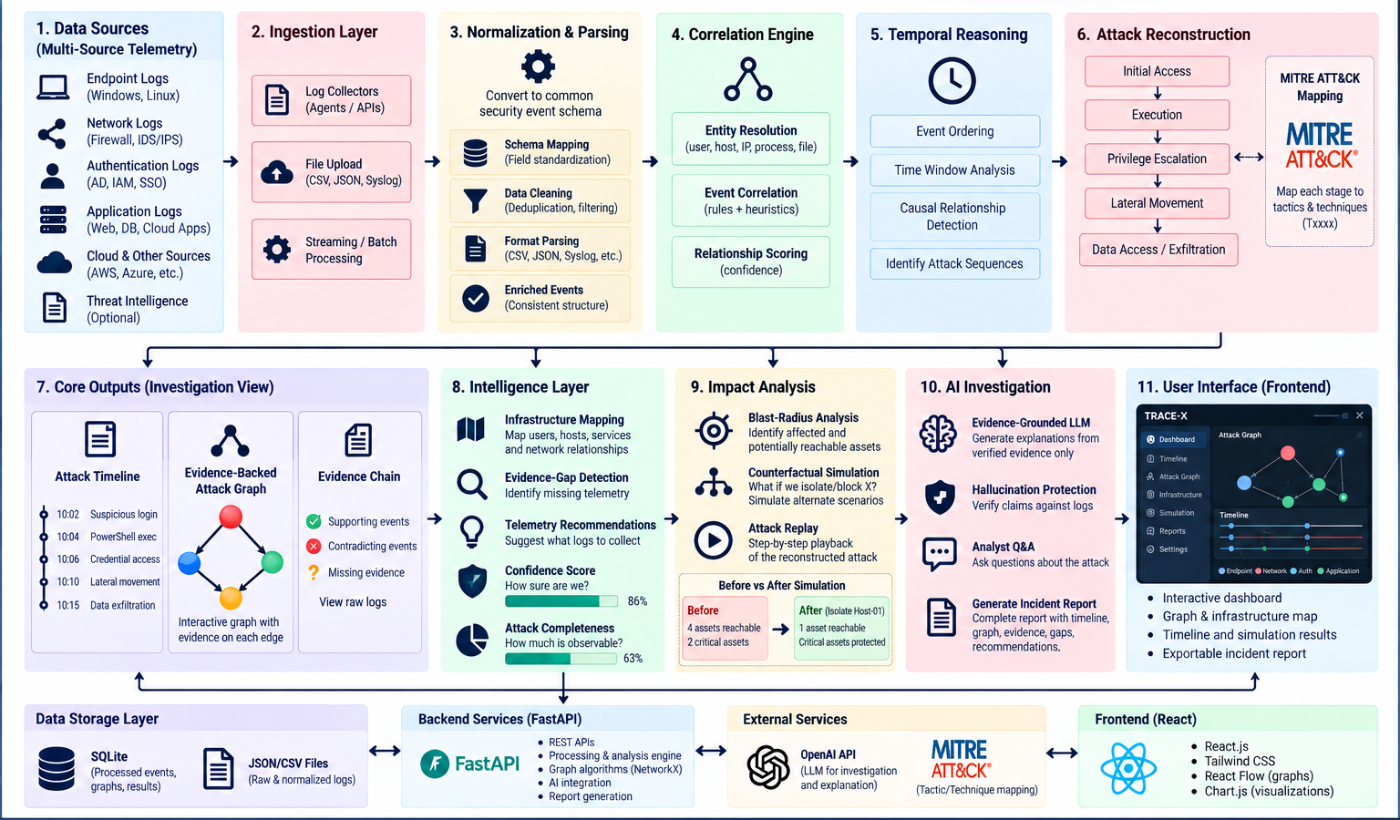

Working / Implementation Approach

- Telemetry Ingestion: Endpoint, network, authentication, and application logs are collected through file uploads or APIs in formats such as CSV, JSON, and Syslog.

- Normalization & Parsing: Logs from different sources are parsed, cleaned, and converted into a common event structure containing fields such as timestamp, user, host, IP address, event type, action, and severity.

- Event Correlation: Related events are identified using shared entities such as users, hosts, IP addresses, processes, and files, along with event relationships and temporal proximity.

- Temporal Reasoning: Correlated events are ordered chronologically and analyzed within relevant time windows to identify possible causal relationships and attack sequences.

- Attack Reconstruction: The system connects related events into a multi-stage attack path, representing stages such as initial access, execution, privilege escalation, lateral movement, and data access/exfiltration.

- Evidence & Confidence Analysis: Each relationship in the reconstructed attack is linked to supporting telemetry. Argus-X calculates a confidence score and an attack-completeness score, while identifying missing or contradictory evidence.

- Infrastructure & Impact Analysis: The reconstructed attack is mapped across users, hosts, services, and assets. The system estimates the potential blast radius and allows counterfactual scenarios, such as isolating a compromised host, to be evaluated.

- AI-Assisted Investigation: Only verified evidence and analysis results are provided to the LLM for natural-language explanations and analyst Q&A. Generated claims are checked against available evidence to reduce unsupported conclusions.

- Visualization & Reporting: The final results are presented through an interactive dashboard containing the attack timeline, evidence-backed graph, infrastructure map, confidence/completeness metrics, simulation results, evidence gaps, recommendations, and incident report.

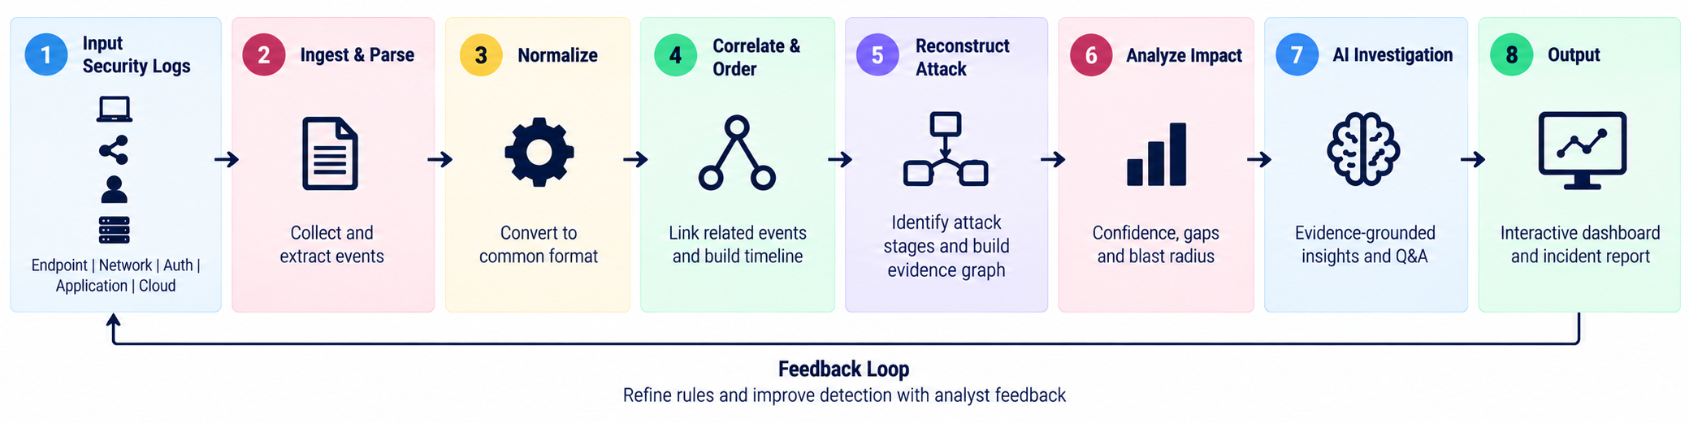

AI/ML Details
The LLM acts as an evidence-grounded investigation assistant. It receives structured attack evidence and analysis results, generates natural-language explanations, and supports analyst Q&A.

AI Model: OpenAI API for natural-language attack explanations and analyst Q&A.
AI Role: AI is used only after the system has verified the evidence, helping analysts understand the reconstructed attack in natural language.
Evaluation: The system is evaluated on correlation quality, attack timeline accuracy, explainability, confidence scoring, and identification of missing evidence.
GitHub Repository Link

https://github.com/bhavikasawant29-hue/Argus-X

☐ I confirm that the solution submitted by our team is developed during the hackathon. We have not submitted a pre-built project as our primary solution. Any open-source code, APIs, datasets, libraries, templates, or AI-assisted development used by us have been appropriately acknowledged.

Open-Source / External Resources Used

- MITRE ATT&CK: Used as the reference knowledge base for mapping reconstructed attack stages to adversary tactics and techniques.
- Synthetic Security Telemetry: Organizer-provided and/or team-generated synthetic endpoint, network, authentication, and application logs used for testing attack reconstruction.
- OpenAI API: Used for evidence-grounded natural-language investigation and analyst Q&A.
- Open-Source Libraries: React Flow, NetworkX, Pandas, and other standard libraries used to implement graph visualization and telemetry processing.
- Research References: Concepts from SLEUTH, Tactical Provenance Analysis, and related attack-reconstruction research were studied to inform the system design.

AI Tools Used
- ChatGPT: Ideation, architecture planning, debugging, and documentation.
- Perplexity: Research
- Claude: Code assistance, logic review, and debugging.
- Manus: Frontend development UI generation, and frontend implementation.
- Antigravity: Development assistance, code generation, and implementation support.
- Figma : UI/UX design, wireframes, dashboard design, and prototyping
- FreeBuff : AI assisted development
- Vercel :Deployment and hosting of the web application
- Canva: Presentation and Pitch Desk
SECTION 6 — UPLOADS / ATTACHMENTS CHECKLIST

☐ Technical Flow / Architecture Diagram
☐ Research / Reference Document (if applicable)
☐ Project Documentation / Technical Report
☐ GitHub Repository Link
☐ Screenshots of Working Prototype
☐ Dataset / Sample Data (if applicable)
☐ Additional Diagrams (if any)

Team Leader Signature: _____________________________ Date: _______________

